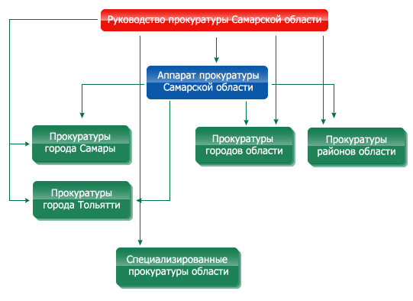
Administration of the Public Prosecution of the Samara region
Office
of the Public Prosecution
of the Samara region
Public Prosecution
of the city Samara
Public Prosecution
of the region cities
Public Prosecution
of the region districts
Public Prosecution
of the city Togliatti
Specialized Public Prosecution offices
of the region

Administration of the Public Prosecution of the Samara region
Office of the Public Prosecution of the Samara region
Public Prosecution of the city Samara
Public Prosecution of the city Togliatti
Public Prosecution of the region cities
Public Prosecution of the region districts
Specialized Public Prosecution offices of the region

http://www.samproc.ru/structure/

Administration of the Public Prosecution of the Samara region

Prosecutor of the Samara region, 3-Class State Counsellor of Justice
Yuri Dmitrievich Denisov

First Deputy Prosecutor of the Samara region, Senior Counsellor of Justice
Eduard Mikhailovich Lopatin

Deputy Prosecutor of the Samara region, Senior Counsellor of Justice
Aleksander Fedorovich Galuzin

Deputy Prosecutor of the Samara region, Senior Counsellor of Justice
Sergei Nikolaevich Shesternin

Deputy Prosecutor of the Samara region, Senior Counsellor of Justice
Vilen Anatolievich Zatsepin

Office of the Public Prosecution of the Samara region

Senior assistant on cooperation with representative (legislative) and executive authorities
Elena Vladimirovna Volkova
Telephone 340-02-75

Senior assistant on inherent security
Viktor Nikolaevich Dedov
Telephone 333-26-45

Senior assistant on regulatory support
Sergei Aleksandrovich Mochalov
Telephone 332-00-80

Senior assistant on media relations
Uliana Sergeevna Kudinova
Telephone 332-01-05

HR DEPARTMENT
Head – Andrei Nikolaevich Zakharov
Telephone 332-13-98

ORGANIZATIONAL DEPARTMENT
Head of the Department – Aleksander Nikolaevich Zherebtsov
Telephone 340-61-84

